STFC SUMMER SCHOOL REPORT - AGREEMENT NO 4070308884
From Stardust to Extrasolar Planets: Dynamics of exoplanetary and solar system bodies
14th international Summer School in Celestial Mechanics Theory and Applications (CELTA-Cortina series)
77th Scottish Universities Summer School in Physics (SUSSP)
Director: Prof Bonnie Steves, Glasgow Caledonian University, B.Steves@gcu.ac.uk , 10 February 2024

University of the Highlands & Islands (UHI), Sabhal Mòr Ostaig, Skye & UHI Inverness, Scotland, 15 - 27 August 2022

1. Aim of this School: To stimulate the cross-fertilisation of ideas between the communities who work in exoplanetary and solar system dynamics and understand the latest tools and methods of analysis necessary for research into exoplanets, solar system bodies and planetary systems.
Website: www.astrocelta.org

2. Venues: Inverness College and Sabhal Mòr Ostaig College, University of the Highlands and Islands
Accommodation and the conference facilities at both venues were outstanding. Sabhal Mòr Ostaig, the Gaelic College, situated on the Isle of Skye off the west coast of Scotland, is an ideal location for the summer school. It is relatively secluded and quiet, yet within easy access of the mainland towns via the Skye bridge. The location on Skye is stunning surrounded by incredible landscapes and sea views. Catering was good, and especially so at Inverness College where the chef regularly produced the best freshly made vegetarian meals. In both venues, the price was very reasonable and the service was exceptional. We would highly recommend both colleges as a Summer School venue.

3. Covid health and safety and student mental health and well-being
The summer school was one of the first summer schools to be delivered in person just after covid restrictions started to be relaxed. Covid health and safety measures were integrated into the summer school delivery leading to careful group and team building and expectations of care and respect for others and their well-being. We were acutely aware that people were coming from all over the world, from varying country restrictions and personal backgrounds of challenges faced during the covid pandemic. This summer school had been deferred twice since it first won funding from STFC to be held in 2020 and 2021. We were determined to run the summer school in person, so as to rebuild a strong sense of connection and belonging to the research community; something that had been seriously weakened with the pandemic lockdowns over the last 2 years. Beginning the school at Inverness College for 4 days first before moving on to Skye worked out very well. We requested that all respected covid health and safety rules to help each other stay well. We provided covid tests for everyone to test upon arrival and then they also tested after 4 days before gathering in closer proximity together taking the specially hired coach from Inverness to Skye, via a tour of the Scottish Highlands. This day tour was one of the highlights of the Summer School, enabling people to connect, socialise and enjoy outdoor tours of the history and landscapes: of Loch Ness, Urquhart Castle; of the west coast, Eilean Donan Castle; and of the peninsula of Sleat, Skye. Respect and dignity and awareness of people’s mental health and well-being were embedded in everything we did at the Summer School.

4. Programme Calendar and daily Timetable for study day
Monday | Tuesday | Wed | Thurs | Fri | Sat | Sun
15 Inverness  Travel to Inverness | 16 Inverness | 17 Inverness | 18 Inverness | 19 Skye – Tour of Highlands &  Travel to Skye | 20 Skye  Public Talk – Rock around the Moon | 21 Skye
22 Skye  Evening round table – Creative arts & astronomy | 23 Skye – Free time,hill-walk, distillery tour, Gaelic culture | 24 Skye  Ceilidh | 25 Skye  Concert in the pub (put on by participants) | 26 Skye  Gala dinner | 27 Depart  Travel ferry to Mallaig | 28

Colour Key | Arrival and Departure | Study day + evening social | Extra-curricular activities day | coffee/lunch/dinner break

Times AM | Study day | Times PM | Study day
09:00 – 10:00 | Lecture | 15:00 – 16:00 | Lecture
10:00 – 11:00 | Lecture | 16:00 – 16:30 | Tea/coffee break
11:00 – 11:30 | Tea/coffee break | 16:30 – 17:30 | Workshops & Seminar sessions
11:30 – 12:30 | Lecture | 17:30 – 18:30 | Dinner
12:30 – 15:00 | Lunch | 19:00 – 20:30 | Evening activity/social event

5. Funding Support
Expenditure | Cost (£) | Subtotal (£) |  | Budget STFC | Cost (£) STFC | Subtotal (£) STFC
Lecturers
Travel expenses | 4825.81 |  |  | 5490.00
Accommodation/meals/refreshments/venue hire - 12 persons | 12083.65 | 16909.46 |  | 20400.00 | 5949.33 | 5949.33

Delegates
Living expenses – 12 days - 10 STFC & self-supporting | 10855.00 |  |  | 42920.00 | 10855.00 | 10855.00
Living expenses – 27 non-STFC students | 22896.15 | 33751.15

Accompanying persons
Living expenses – 6 persons | 2159.00 | 2159.00

Other costs
Transport: Coach & Ferry travel | 2459.20 |  |  | 2000.00 | 2000.00
Phone/Postage/Wi-Fi/photocopying/consumables | 551.60 |  |  | 1500.00 | 551.50
Management fees | 500.00 |  |  | 500.00 | 500.00
Entertainment/Excursions (Urquhart Castle, Ceilidh) | 1117.55 | 4628.35 |  | 1000.00 | 1000.00 | 4051.60
Total Cost |  | 57447.96 |  | 69310.00 |  | 20855.93
Income | Funds | Subtotal
SUPA & SUSSP for EU/International lecturer expenses, social expenses & support for non-STFC UK and international students | 20000.00 |  |  | 20000.00
Student fees from non-STFC UK and international students | 14433.03
Accompanying persons living expenses | 2159.00
Total income |  | 36592.03
Final payment requested from STFC |  | 20855.93

6. Attendance
Distribution of Lecturers and participants Gender identity of lecturers and students
Participants | 35 |  | Gender | Lecturer | Student | Total
Lecturers in person | 12 |  | Male | 10 (56%) | 24 (69%) | 34 (64%)
Lecturers online | 6 |  | Female | 5 (28%) | 11 (31%) | 16 (30%)
Total | 53 |  | Prefer not to say | 3 (16%) | - | 3 (6%)

Breakdown of countries for lecturers and students
UK 18; Italy 9; Belgium 5; Austria 3; Netherlands 3; Germany 3; France 2; Greece 1; Romania 1; USA 3; Brazil 4; Argentina 1; New Zealand 1. 13 countries

Ethnicity of lecturers and students: Any other white 28 (53%); white British 8 (15%); white (Irish) 1 (2%); rather not say 7 (13%); other ethnicity group 3 (6%); Chinese (or Chinese British) 2 (4%); Asian (or Asian British) 2 (4%); any other Asian 1 (2%); any other mixed 1 (2%).

Disability for lecturers and students: None 38 (72%); prefer not to say 8 (15%); have a physical disability 3 (6%); have a long-term mental health condition 3 (6%); have a learning difference 1 (2%).

Age distribution: Students: 21-25 7 (20%); 26-30 21 (60%); 31-35 7 (20%).
Lecturers: 51-60 6 (33%); 61-70 3 (17%); over 70 3 (17%); prefer not to say 6 (33%).

The participant numbers were good considering the School was only confirmed in April 2022 to be going ahead for Aug 2022, once covid restrictions were being relaxed and countries were opening up to allow international travel. We had 82 applications, with 62 offers made. Of these, 37 navigated all the challenges to arrive at the Summer School. There was quite a volatility of registration, with participants facing the severe challenges of rising costs of travel that occurred in 2022, difficulties in getting visas and renewed passports in time, limited financial support from their institutes, reduced availability of flights and travel disruptions with rail strikes in the UK and cancelled transport due to driver illness or understaffing. We had a similar volatility in our lecturers being able to attend in person, with 6 deciding after much careful thought to deliver their lectures online and not to risk covid with attendance and travel in person. All other lectures and events were delivered solely in person. For most participants, this was the first in person conference type gathering they had had in two years and for many the first in person event attended as a PhD student. We had a good gender balance with 31% female students and a good distribution of students and lecturers from 13 countries from the UK, Europe, North America, South America and New Zealand. NB The UK sector average for female PhD students in Physics was 25% in 2022.

7. Lecturers, Tutorials and Topics
Invited Lectures and Textbook chapter titles | Lecturers
I Celestial Mechanics Theories and Tools  Resonances: Secondary Resonances inside mean motion resonances  Fundamentals of regularization theory  Perturbation theories in Celestial Mechanics  The usefulness of action-angle variables in Celestial Mechanics  Homoclinic and Heteroclinic chaos: from Poincare to modern computer tools  II Star Dust & Solar System Bodies  Dust and space debris  Orbit determination for solar system bodies  The analytical theory of close encounters of small bodies and planets, with application to the NEA hazard (keyhole theory) and to the chaotic dynamics in the outer planetary region  Dynamics of Rubble Piles  Trajectory design for interplanetary exploration  Planetary defence and asteroid deflection  From NEOs to TNOs: A journey through asteroids in our Solar System  Near Earth Objects: Observe, Predict, and Protect  III Extrasolar Planets & Exoplanetary Systems  Giant Planets from interiors to atmospheres  Gravitationally unstable discs and direct formation of planets  Planet demographics and our cosmic context  Physics of the Universe & Chemistry for Life  Tides and Exoplanets  Celestial mechanics applications to post-main-sequence planetary systems  Polarimetry for planet characterisation | Anne Lemaitre, Universitie de Namur, Belgium  Bonnie Steves, Glasgow Caledonian University and Winston Sweatman, Massey University, New Zealand  Alessandra Celletti, Università di Roma 'Tor Vergata', Italy  & 5. Christos Efthymiopoulos, University of Padova, Italy  6. Catalin Gales, University of Iasi, Romania  7. Giovanni Gronchi, Università di Pisa, Italy  8. Giovanni B. Valsecchi, Instituto Nazionale di Astrofisica, Italy  9. Daniel J Scheeres, University of Colorado, USA  10. & 11. Massimiliano Vasile, University of Strathclyde, UK  12. Rudolf Dvorak, University of Vienna, Austria  13. Ettore Perozzi, Italian Space Agency, Rome, Italy  14. Yamila Miguel, Leiden Observatory, Netherlands  15. Ken Rice, University of Edinburgh, UK  16. & 17. Martin Dominik, University of St Andrews  18. Sylvio Ferraz-Mello, Universidade de Sao Paulo, Brazil  19. Dimitri Veras, University of Warwick, UK  20. Daphne Stam, University of Delft

8. Summer School learning in research, student well-being/EDI, career development and public engagement
The students were encouraged to develop groups of similar research areas and create their own seminar sessions. Every student produced a poster and then developed a 5 minute talk on their research, which they presented as part of their team in 30 minute sessions. The well-being and respect for each other was emphasised throughout – that all should work together as a team. Each team had the guidance of one of the invited lecturers. The level of science was excellent. This mode of research team building and presentation was very successful, with life-time friendships and collaborations begun. The concert by the participants was particularly moving, with people sharing their poetry and stories and music developed over the last few years of covid. There was much that was sharing and healing after the isolation and traumas of the world-wide pandemic and some wonderful celebrations of togetherness through singing and music. The final Gala dinner evening and speeches reminiscing on past Summer Schools and the future ended with an emotional standing ovation.

Advice on their research and career development in academia, related industries, space agencies and space technologies was given by the lecturers and ECRs. Career experiences in academia and related industries were shared within the teams. Dr Ettore Perozzi, renowned Italian author, presented his acclaimed Rock around the Moon to participants and the local Skye community. We also held an evening round table discussion on developing Astronomy public outreach and the participants shared their creative activities during the lockdowns of joining the Arts and Astronomy for the public. Participants received digital copies of the lectures and a Graduate Textbook is being created from the invited lectures for wider publication and dissemination.

9. Feedback from the lecturers and students
100% of the participants found the summer school good and would recommend it to others. Coming together after two years of isolation and lockdown was incredibly moving. Many said it was the best summer school they had ever attended. They enjoyed particularly the lecture programme which was well delivered by the lecturers, very useful and interesting; and the social programme which allowed them to quickly get to know one another. The free days for hill-walking, guided walks on gaelic culture, and tours of Scottish historic sites; and the social evening events of the concert by the participants and the ceilidh dance were especial favourites.

10. Recommendations for future schools the use of Inverness and Sabhal Mòr Ostaig colleges, UHI as venues; the creation of a strong research culture and sense of belonging to a scientific community through the research seminar groups and social activities of free days and social evenings of concert and ceilidh; the retention of a solely in person experience for participants and lecturers, not hybrid, with the dissemination of lecture material to wider audiences post-school through online and textbook publication. Helpful improvements – much earlier confirmation of the summer school going ahead, of student places agreed and of financial transactions completed.

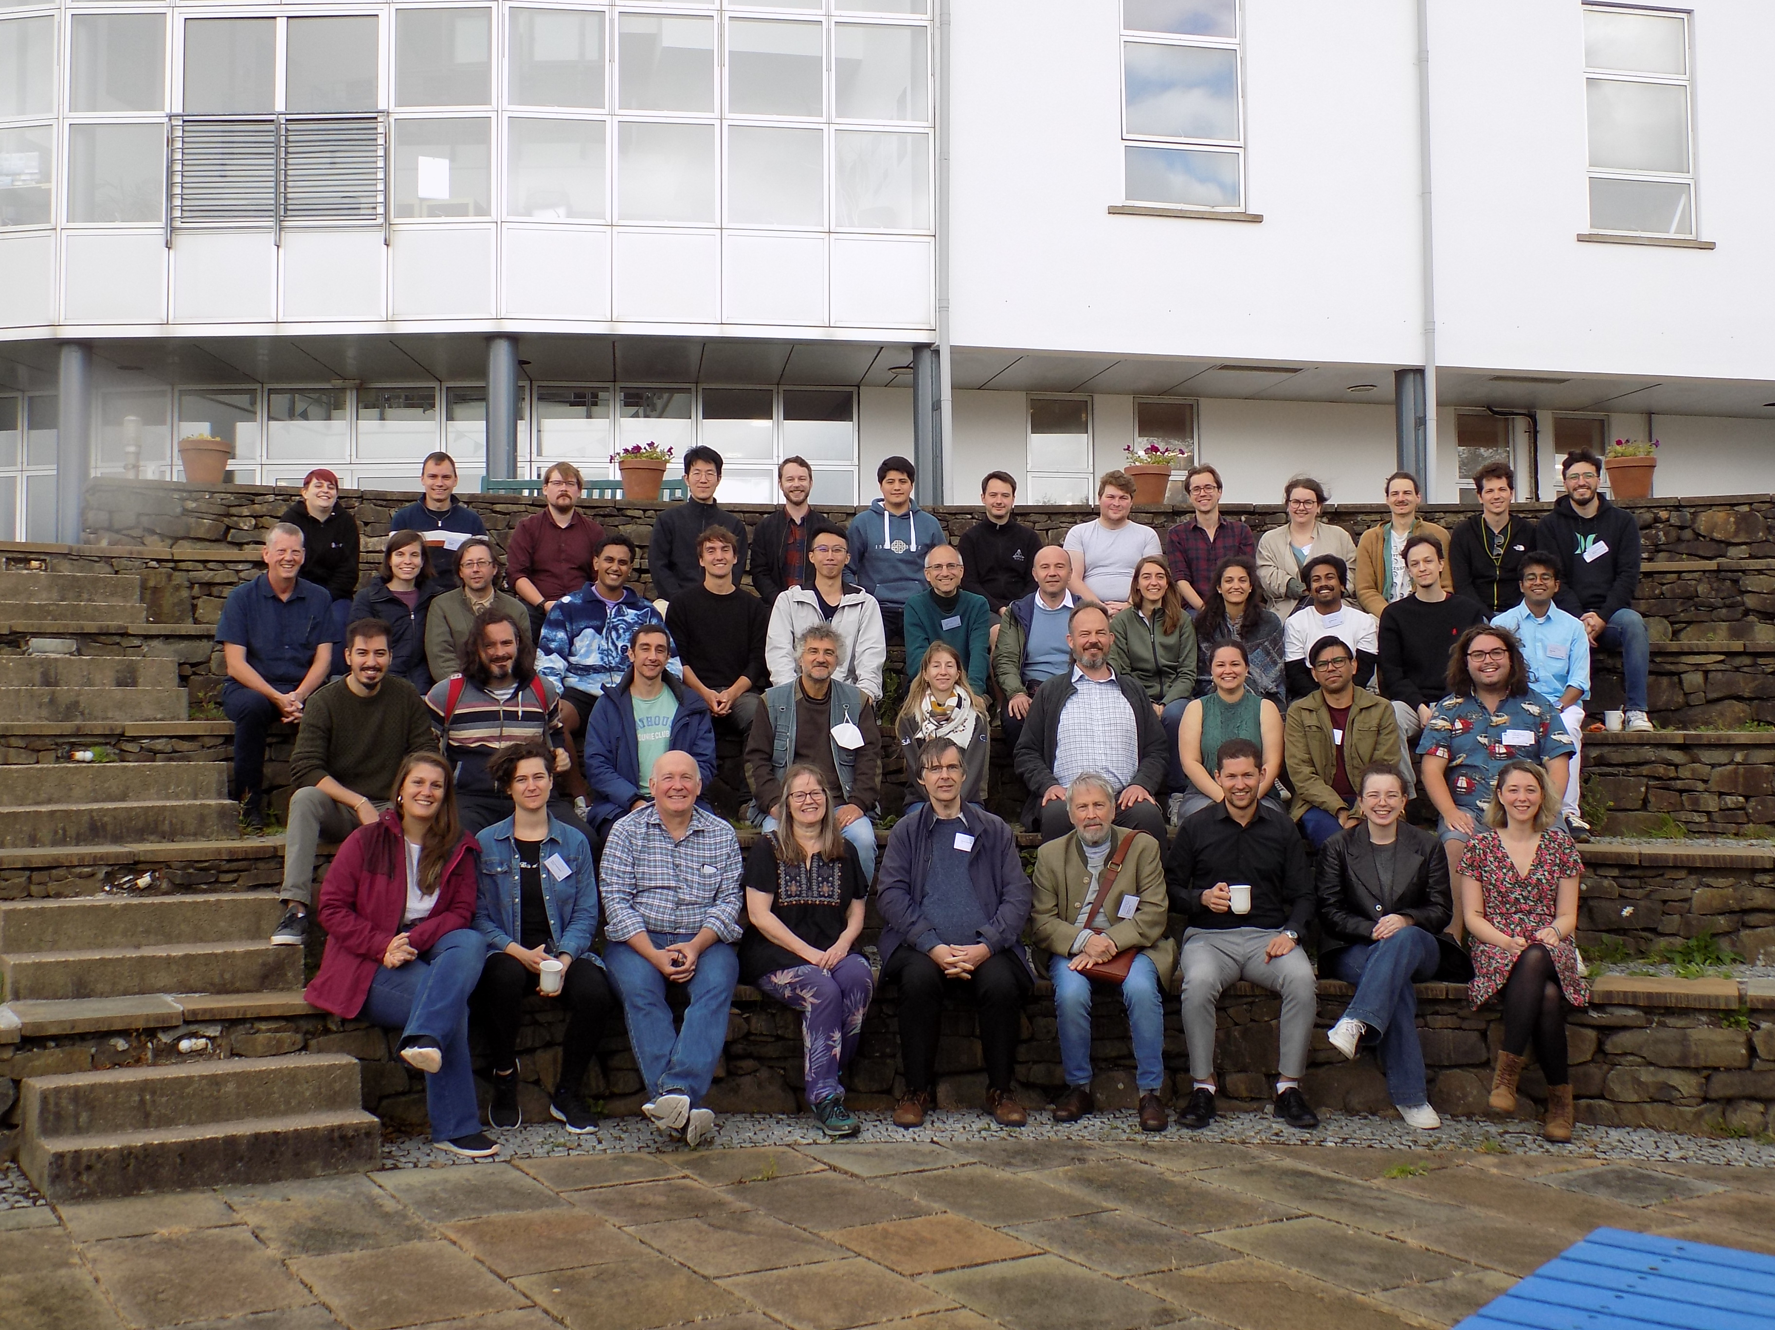

Some quotes from the students:
I'd like to take this opportunity once again to thank you for the huge opportunity I had to be part of this group, as well as for all of your support and assistance throughout the event. It was amazing!

I just wanted to thank you for the wonderful experience that I had at the summer school. You were such an amazing organizer and host. Apart from all the great lectures, you made us feel so comfortable with your friendliness, approachability, and concern for our well-being. I loved that Peter and Jennie [Scottish musician/gaelic speaking family members of the organisers] helped you in the organization in their own ways. It was such a pleasure meeting them too. Our hike to Suisnish will remain one of the most memorable experiences for me. Learning about the history of the place and hearing you all sing and play the whistle was a magical experience. It was really great getting to know everybody! I hope our paths cross again in the future.

It was again a great summer school from the point of view of science AND social contacts!! Many thanks again!

Let me take the opportunity to warmly thank you once more for one of the best event so far I've had the pleasure to take part in!

Thanks again for the nice summer school! I hope it was equally interesting and fun for the organizers as it was for us participants.

Thanks for a very interesting CELTA summer school on Skye.

